MINI PROJECT

DODGE THE BLOCKS

Team Members:
Vineet Kumar
2101CS83
Overview of Game :
The player has to dodge the blues block moving horizontally and cross the redline to win the game.
If we it any one of the block, we will lose the game.
The game has two post screen for win and loose.
And the user can restart the game by pressing the button 3rd.
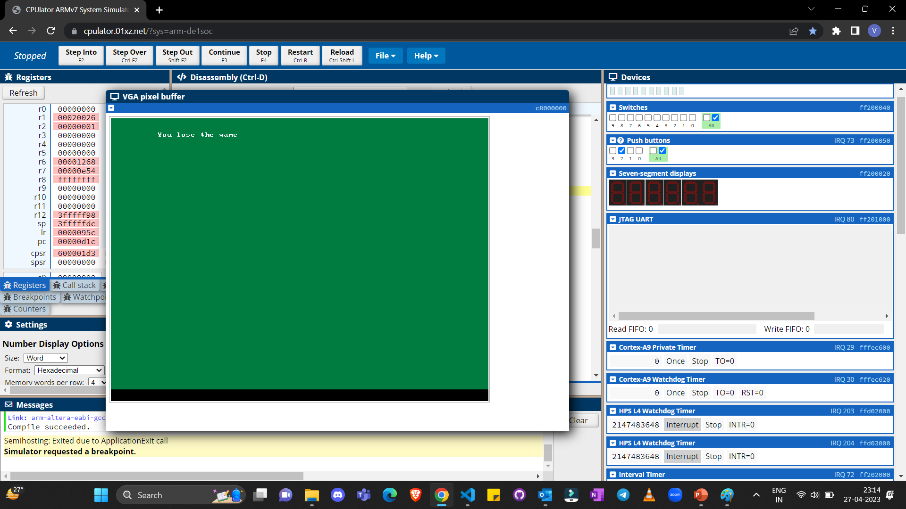
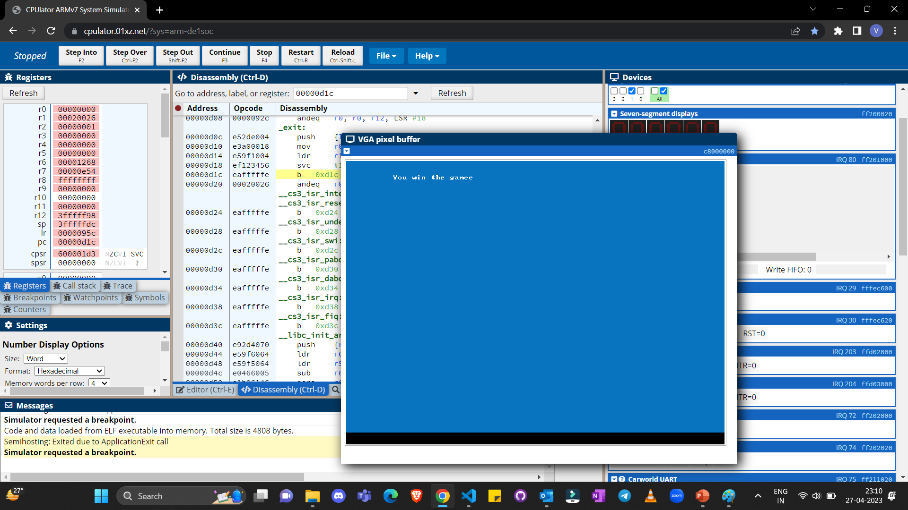

Functionality of the Game :
The game start in main() function , and we use a infinite while loop to constantly move the rectangles horizontally and use draw_rectangles()function to overwrite and also the player function to show player() and we use a function move_player() to update the player position using the buttons, and the delay function to slow the program. If the player hit the rectangle it would come out of while loop and new screen would be prompted win/loose.

Functions Used:
- draw_rectangle() // to make blocks
- void draw_rectangle(int x, short int c)
- {
- for (int i = x; i < x + 21; i++)
- {
- for (int j = 40; j < 61; j++)
- {
- write_pixel(i, j, c);
- }
- }
- }

- player() // to draw players

void player(int x, int y, short int c)
{
for (int i = x; i < x + 5; i++)
{
for (int j = y; j < y + 5; j++)
{
write_pixel(i, j, c);
}
}
}

- move_player // update player position

- // move left
- if (move == 4)
- {
- delay();
- delay();
- player(playerX, playerY, 0);
- if (x > 20)
- playerX -= 20;
- }

- delay() // to add delay in program

void delay()
{

volatile int *pixel_ctrl_ptr = (int *)0xff203020;
int status;
*pixel_ctrl_ptr = 1;
status = *(pixel_ctrl_ptr + 3);

while ((status & 0x01) != 0)
{

status = *(pixel_ctrl_ptr + 3);
}
}

- pushbuttons of arm desoc1 board() 0xff200050 // to control the player movement
Buttons Used :
They are used from the board to control the player movement.
- Button 0 – is used to move the player up
- Button 1 – is used to move the player down
- Button 2 – is used to move the player left
- Button 3 – is used to move the player right, also is used to restart the game after user has win or lose

VGA SCREEN :

/* set a single pixel on the screen at x,y
* x in [0,319], y in [0,239], and colour in [0,65535]
*/
/* write a single character to the character buffer at x,y
* x in [0,79], y in [0,59]
*/

Language used : C
Board Used : ARM DESOC-1

Thank You

